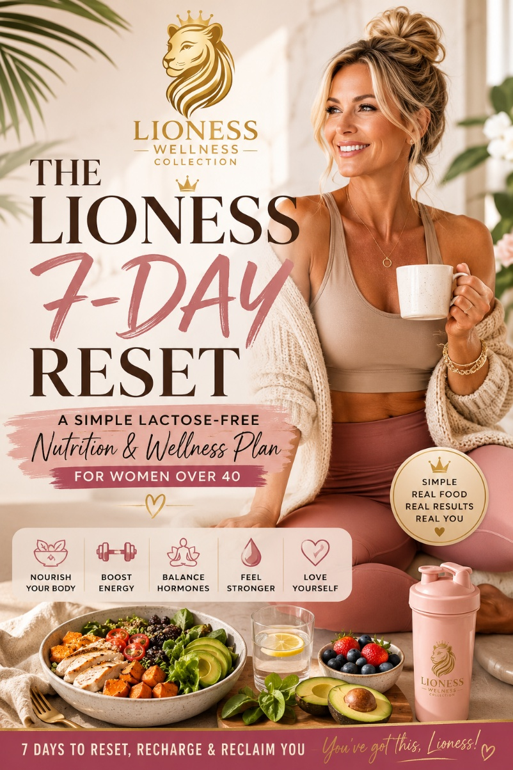

IMPORTANT DISCLAIMER
Before commencing any nutrition plan, exercise program, supplement regimen or lifestyle change, please consult your doctor, healthcare provider, dietitian or qualified health professional.
This guide is intended for educational and informational purposes only.
The information contained within this guide is not medical advice and should not replace professional medical assessment, diagnosis or treatment.
Every woman is different. Individual results may vary depending on age, health status, medications, hormonal status, activity levels and personal circumstances.
The author accepts no responsibility or liability for any injury, illness, loss, adverse reaction or consequence resulting directly or indirectly from the use of this guide.
By choosing to follow this plan, you accept full responsibility for your own health decisions.

WELCOME LIONESS
If you are over 40 and struggling with:
• Weight gain
• Low energy
• Cravings
• Menopause symptoms
• Poor sleep
• Lack of motivation
• Feeling overwhelmed by diets
You are not alone.
This guide has been designed to simplify nutrition.
No complicated meal plans.
No expensive ingredients.
No starvation.
Just real food.
Real movement.
Real results.

WHAT RESULTS CAN I EXPECT?
Most women who follow this plan consistently may experience:
✓ Less bloating
✓ More energy
✓ Better digestion
✓ Better sleep
✓ Improved strength
✓ Reduced cravings
✓ Improved confidence
✓ 1–4kg weight loss during the first month
Some women may lose more.
Some women may lose less.
The goal is not rapid weight loss.
The goal is creating habits that last.

HOW TO CALCULATE YOUR MACROS
Macros simply means:

Protein
Builds muscle and keeps you full.

Carbohydrates
Provide energy.

Fats
Support hormones and overall health.

SIMPLE METHOD
You do not need complicated calculations.
At every meal:
🥩 Protein = Palm-sized serve
🥦 Vegetables = Half your plate
🥔 Carbohydrates = Fist-sized serve
🥑 Healthy fats = Thumb-sized serve

EXAMPLE FOR A 90KG WOMAN
Protein:
150–180g daily
Fat:
60–80g daily
Carbohydrates:
100–150g daily
Calories:
Approximately 1700–1900 daily

THE LIONESS SHOPPING LIST

PROTEIN
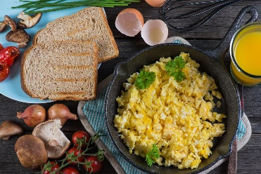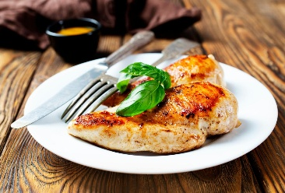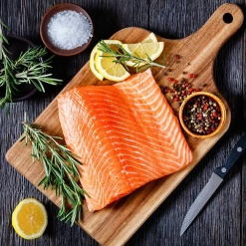

✓ Eggs
✓ Chicken breast
✓ Chicken thighs
✓ Lean beef mince
✓ Salmon
✓ Tuna
✓ Prawns
✓ Tinned tuna
✓ Tinned salmon
✓ Turkey mince
✓ Lactose-free protein powder

VEGETABLES
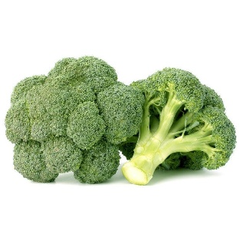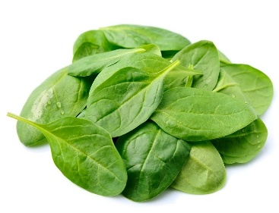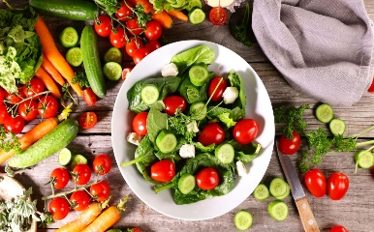

✓ Broccoli
✓ Cauliflower
✓ Spinach
✓ Lettuce
✓ Cucumber
✓ Tomatoes
✓ Capsicum
✓ Carrots
✓ Green beans
✓ Zucchini
✓ Mushrooms
✓ Avocados

FRUIT
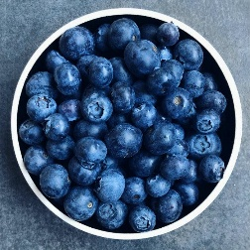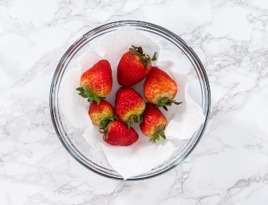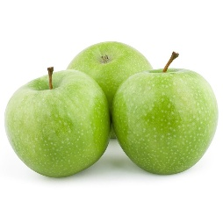

✓ Berries
✓ Apples
✓ Pears
✓ Oranges
✓ Watermelon
✓ Kiwi fruit

HEALTHY FATS

✓ Olive oil
✓ Avocados
✓ Almonds
✓ Walnuts

✓ Chia seeds
✓ Pumpkin seeds
✓ Natural peanut butter

CARBOHYDRATES

✓ Oats
✓ Rice
✓ Sweet potato
✓ Quinoa
✓ Wholegrain wraps
✓ Wholegrain bread

BREAKFAST OPTIONS

OPTION 1

Lioness Protein Breakfast
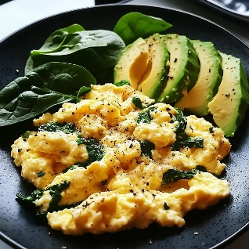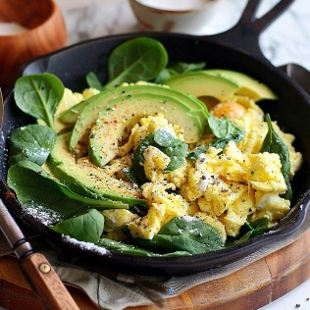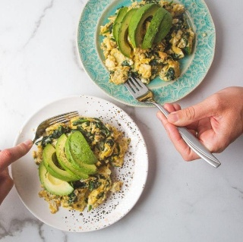

Ingredients
• 3 eggs
• Handful spinach
• ½ avocado
• Salt & pepper

Method
- Heat a non-stick pan.
- Add spinach.
- Cook for 1 minute.
- Add whisked eggs.
- Stir gently until cooked.
- Serve with avocado.
Protein:
Approximately 25g

OPTION 2

Chia Berry Pudding

Ingredients
• 2 tbsp chia seeds
• 1 cup unsweetened almond milk
• ½ cup berries
• Cinnamon

Method
- Combine chia seeds and almond milk.
- Refrigerate overnight.
- Add berries and cinnamon before serving.
Protein:
10–15g

LUNCH OPTIONS

OPTION 1

Chicken Salad
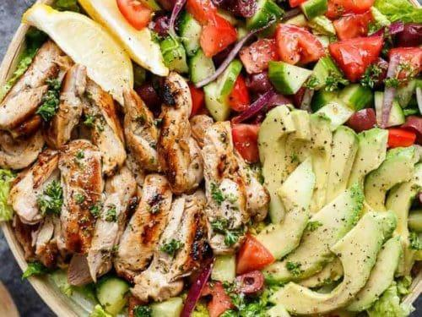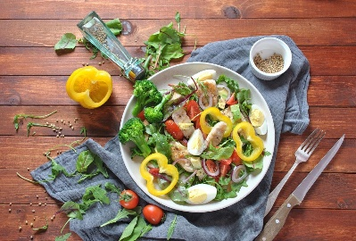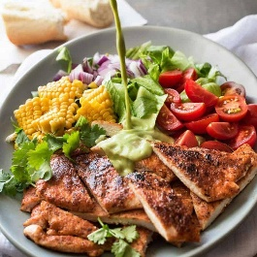

Ingredients
• 150g chicken breast
• Lettuce
• Cucumber
• Tomato
• Avocado
• Olive oil

Method
- Grill chicken for 5–6 minutes each side.
- Chop vegetables.
- Slice avocado.
- Add chicken.
- Drizzle olive oil.

OPTION 2

Tuna Protein Bowl

Ingredients
• 1 tin tuna
• Salad leaves
• Cucumber
• Capsicum
• Avocado

Method
- Drain tuna.
- Combine vegetables.
- Add avocado.
- Mix and serve.

DINNER OPTIONS

OPTION 1

Salmon & Vegetables
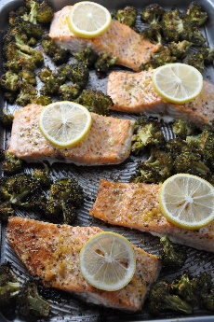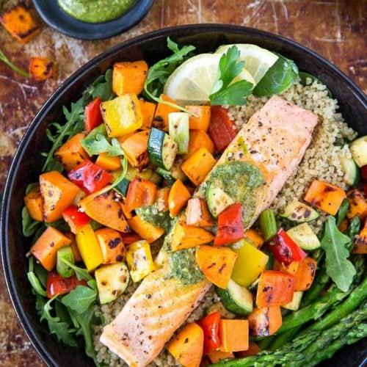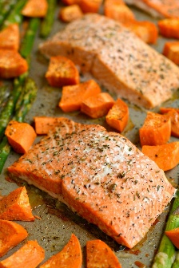

Ingredients
• 150g salmon
• Broccoli
• Sweet potato
• Olive oil

Method
- Bake salmon at 180°C for 15 minutes.
- Steam broccoli.
- Bake sweet potato.
- Serve together.

OPTION 2

Beef Stir Fry

Ingredients
• 150g lean beef strips
• Capsicum
• Broccoli
• Carrot
• Coconut aminos or soy sauce

Method
- Cook beef.
- Add vegetables.
- Stir fry 5–7 minutes.
- Add sauce.
- Serve.

SNACK OPTIONS
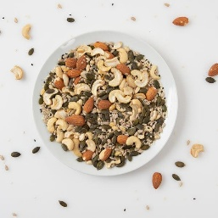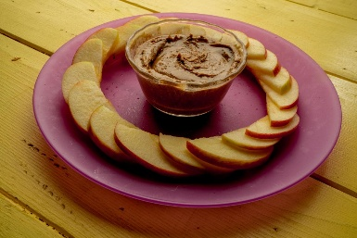

Choose 1–2 daily:
✓ Boiled eggs
✓ Apple
✓ Almonds
✓ Walnuts
✓ Berries
✓ Protein shake
✓ Pumpkin seeds

HYDRATION PLAN

Upon Waking
500ml water

Morning
500ml water

Afternoon
500ml water

Evening
500ml water
Daily Goal:
2–3 litres

RECOMMENDED SUPPLEMENTS
Always consult your healthcare provider before taking supplements.

Magnesium Glycinate
May support:
• Sleep
• Recovery
• Stress management
200–400mg daily

Vitamin D3
May support:
• Bone health
• Immune function
• Muscle health

Omega 3
May support:
• Heart health
• Brain health
• Joint health

Creatine Monohydrate
May support:
• Strength
• Muscle preservation
• Energy production
3–5g daily

Electrolytes
Helpful for:
• Hydration
• Exercise recovery
• Energy

SIMPLE BEGINNER WORKOUT PLAN

Monday
30-minute walk

Tuesday
Strength Training
3 x 10 Squats
3 x 10 Wall Push-Ups
3 x 10 Glute Bridges
3 x 10 Resistance Band Rows

Wednesday
30-minute walk
Stretching

Thursday
Strength Training
Repeat Tuesday

Friday
30–45-minute walk

Saturday
Yoga
Pilates
Stretching
20–30 minutes

Sunday
Rest
Recovery
Meal preparation

DAILY CHECKLIST
□ Protein at every meal
□ 2–3 litres water
□ Walk completed
□ Vegetables eaten
□ Supplements taken
□ Sleep prioritised

THE FOUR PILLARS OF LIONESS HEALTH

1. Nutrition
Fuel your body.

2. Strength
Build muscle.

3. Movement
Walk daily.

4. Recovery
Sleep.
Hydrate.
Rest.

FINAL LIONESS MESSAGE
You do not need another extreme diet.
You do not need to punish yourself.
You do not need to start over every Monday.
You simply need to make the next healthy choice.
One meal.
One walk.
One workout.
One day at a time.
Thirty days from now, you could be stronger, healthier and more confident than you are today.
Start where you are.
Use what you have.
Do what you can.
The Lioness inside you is stronger than you think. 🦁💛

